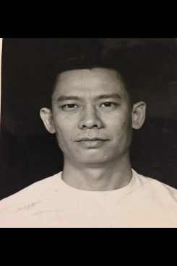

Life is not perfect, but sometimes you find the right path that leads you where you need to be such as in the case of Dr. Yao “Everything just fell into a perfect line”. Dr. Peter Lao Yao was born on October 6, 1926 in Quezon province in the Philippines. Dr. Yao was a teenager during World War Two and lived under the Japanese occupation of the Philippines until the end of the war. Dr. Yao later moved to New York City in the United States where he did his training to become a doctor. He later moved to Saint John, New Brunswick where he gained landed immigrant status with his job as a surgeon at the Saint John general hospital.

Dr. Yao having been raised under the Japanese occupation of the Philippines did not have the easiest childhood or as he described it, “They were tough times, but we made the best of it” . Dr. Yao originally attended engineering school during the end of the war and the years following the war. But in his last year of engineering he dropped out to pursue a career in medicine. Dr. Yao attended University of Santo Tomas medical program in the capital of the Philippines Manila. Dr. Yao graduated medical school in 1957; that same year he got accepted to Mount Sinai hospital in New York city for a residency in their general surgery program. Dr. Yao finished his training at Mount Sinai hospital; at the end of his training he was offered a position at the Old Saint John general hospital in Saint John New Brunswick.

With the offer of a job as a general surgeon at Saint John general hospital Dr. Yao gained landed immigrant status, “I didn't even ask for it” stated Dr. Yao making him a permanent resident, but not yet a citizen of Canada. Dr. Yao officially became a Canadian citizen in 1969. Dr. Yao met and married Dawn May Logan whom was a nurse at Saint John general hospital. They had three children Kim, Krista, and Kara. Doctor and Mrs. Yao have a total of two grandchildren. Dr. Yao practiced medicine for a total of twenty-six and a half years. Dr. Yao moved to Bathurst in 1997, “It's a calm place to settle down” where he has lived in retirement ever since.

Dr. Peter Lao Yao has lived an extraordinary life. One filled with hardships, but also so much joy. He has seen more in his 92 years of life then many of us ever will. He is truly an extraordinary individual. “My life has had its ups and downs, but I'm still here and that's all that counts.”