Outcome – RF1
- Larry and Tony are baking cupcakes and banana mini-loaves to sell at a school fundraiser.
- No more than 60 cupcakes and 35 mini-loaves can be made each day.
- Larry and Tony make at least 80 baked goods, in total, each day.
- It costs $0.50 to make a cupcake and $0.75 to make a mini-loaf.
- They want to minimize the costs to produce the baked goods.

To help them in finding the best solution, I set up the following optimization:
Variables:
Let x = # of cupcakes
Let y = # of banana mini-loaves

Restrictions:
$x∈W, y∈W$

Constraints:
$x≤60$
$y≤35$
$x+y≥80$

Objective Function
$C=0.50x+0.75y$

- Graph the system and show all your work mathematically to accompany the graph. Use a scale of 5 on each axis.

- What is the minimal cost for creating the baked goods, and how many of each must be made to minimize the cost? All work done to arrive at your answer must be shown for full value.

Outcome N2
- Ginny and Susan both have the following investment portfolios as described below.

Ginny’s portfolio:  - a 5-year $3000 GIC that earns 3%, compounded annually, which she purchased 5 years ago.  - a 5-year $1500 CSB that earns 4%, compounded quarterly, which she purchased 5 years ago  - a savings account that earns 2.5%, compounded weekly for 5 years, into which she has been making deposits of $20 each week | Susan’s portfolio:  - a 5-year $1000 bond that earns 2.8% simple interest, which she purchased 5 years ago  - a 5-year $1000 CSB that earns 5%, compounded semi-annually, which she purchased 5 years ago  - a savings account that earns 3.5%, compounded monthly for the past 5 years, into which she has been making monthly deposits of $125

- Determine the current value of each person’s portfolio.

- Calculate each one’s rate of return.

Outcome RF2
- Fill in the table for the relation $y={2x}^{2}-6x-36$.

Direction of the opening

Minimum or Maximum

y-intercept

x-intercept(s)

Vertex

Equation of the Axis of symmetry

Domain

Range

- A school group is selling raffle tickets to raise money. The profit in dollars, y, can be modeled by the following function where x represents the price of each ticket in dollars. $y=-30x^{2}+300x-480$
- What ticket price will result in the group receiving maximum profit, and what is the maximum profit?
- Determine what ticket price(s) will result in the group breaking even, in other words, making no profit.
c) What profit is made when the price of a ticket is $4?
d) What ticket price(s) will yield a profit of $150?
Question 5
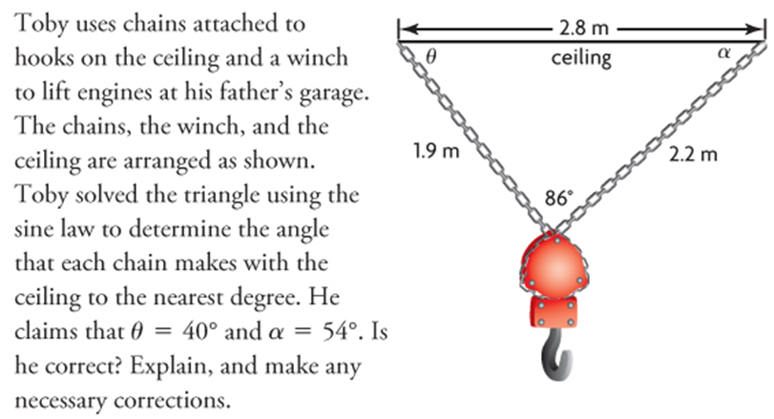
Question 6
A golfer hits a tee shot on a 250 m hole. The ball is sliced to the right and travels 175 m. If the ball is 125 m from the hole, what is the angle of the slice?
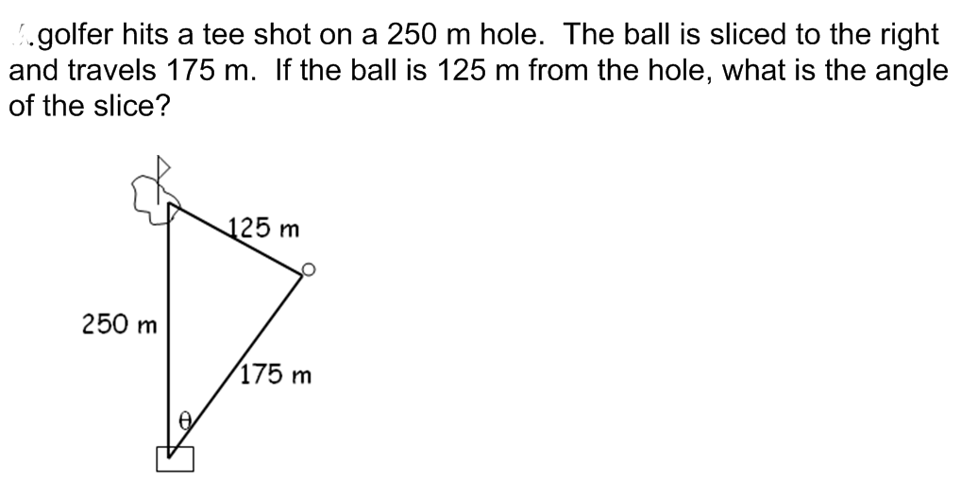
A
Question 7
B
Solve for <C in the following triangle if c=4.3 cm, <A=32° and a=2.5 cm.
C
Determine the missing angles and provide reasons:
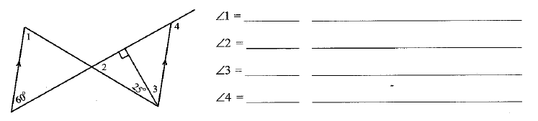

Question 8
What is the sum of the interior angles of a 15-sided polygon?

Question 9
- Find the number of sides of a regular polygon with an interior angle of 162°.

- What is the measure of each exterior angle?

Question 10
