Canadian Geography 12-0
Portraits of the Nation
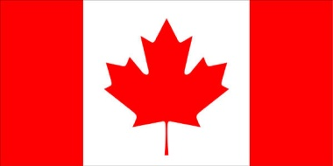
Geography is the study of humanity and its relationship with the natural environment. This course is centered around the study of the ever changing cultural and physical landscapes of Canada and how they impact on each other.
The course is divided into 4 key sections, although there will be some overlap within the sections.
- The physical geography of Canada
  - Latitude and longitude
  - Geology and landforms
  - Climate
  - Soil and vegetation regions
- The composition and distribution of Canada’s population
  - Population patterns and distributuion
  - Ethnic composition and variation
  - Immigration
  - Settlement patterns and urban development
- Management of Natural Resources and industries
  - Primary, secondary, tertiary and quaternary industries
  - Renewable and non-renewable resources
- Canada and the World

Grading Breakdown
Term 1 and 2 35% + 35% 70%
Exam 30%

Within each term
Assignments, journal, projects, presentations 70%
Tests and quizzes 30%

