Broad Based Technology
Energy and Sustainability
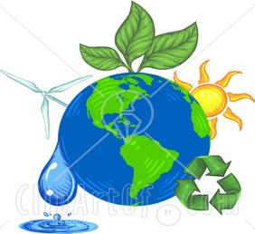

Welcome to Energy and Sustainability!
This term we will be learning about a whole selection of topics on the environment, renewable energy, electricity and sustainability!
Course Topics
The environment then and now
Renewable and non-renewable energy
Energy conversions
Electricity and electric circuits
Marking
Journal, assignments, labs, group activities 50%
Renewable energy project 50%

